<Image Gallery Software>

Use-Case Specification: <View User's Gallery>

Version <1.0>

Revision History

|  |  |  |  |
| --- | --- | --- | --- |
| **Date** | **Version** | **Description** | **Author** |
| <dd/mmm/yy> | <1.0> | <details> | Nguyen Kiem Hoa |
|  |  |  |  |
|  |  |  |  |
|  |  |  |  |

Table of Contents

1. View User’s Gallery 4

1.1 Brief Description 4

1.2 Actor 4

2. Flow of Events 4

2.1 Basic Flow 4

3. Special Requirements 4

4. Preconditions 4

5. Postconditions 4

6. Extension Points 4

Use-Case Specification: <View User's Gallery>

# View User’s Gallery

## Brief Description

This use case defines the steps of viewing user’s gallery which store all user’s image has posted in the software. User can easily view their image with some simple steps.

## Actor

User

# Flow of Events

## Basic Flow

When software is opening, user need click on “Gallery” button on menu bar. Then a list of images which user has been posted will appear. User can easily manage their images there.

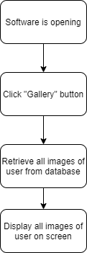

# Special Requirements

User has posted image.

# Preconditions

User click on “Gallery” button.

# Postconditions

A list images of user appear.

# Extension Points

No extension point.